Unit 5

Gender is a symmetric variable. P & Y = 1 and N & A = 0.
So, rewriting the table above:

Name | Gender | Fever | Cough | Test-1 | Test-2 | Test-3 | Test-4
Jack | M | 1 | 0 | 1 | 0 | 0 | 0
Mary | F | 1 | 0 | 1 | 0 | 1 | 0
Jim | M | 1 | 1 | 0 | 0 | 0 | 0

Jaccard’s coefficient:

Name | Gender | Fever | Cough | Test-1 | Test-2 | Test-3 | Test-4
Jack | M | Y | N | P | N | N | A
Mary | F | Y | N | P | A | P | N
Jim | M | Y | P | N | N | N | A
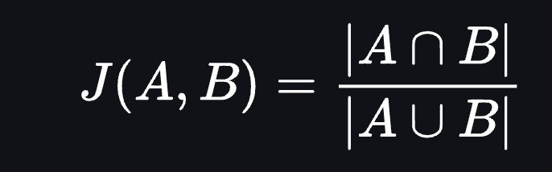

J(Jack, Mary) = (1+1)/(1+1+1) = 0.67
J(Jack, Jim) = 1/(1+1+1) = 0.33
J(Jim, Mary) = 1/(1+1+1+1) = 0.25

